**Data collection part**

**1.Run on separate machines**

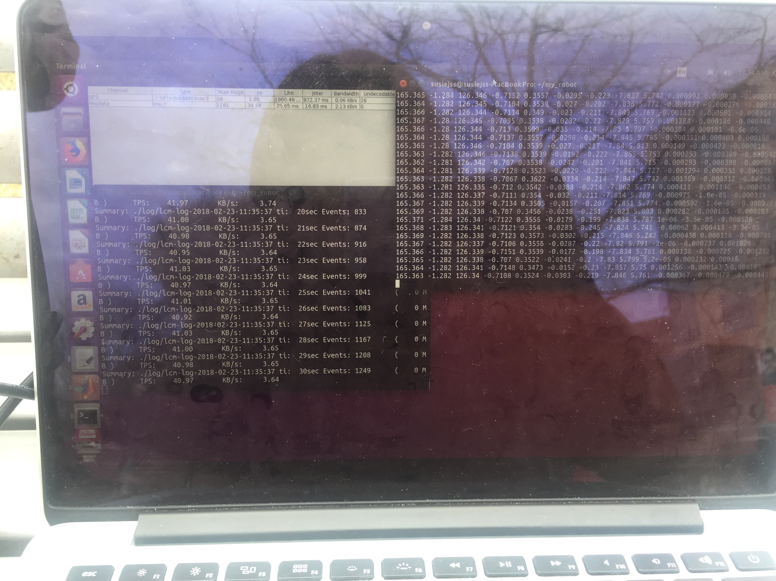

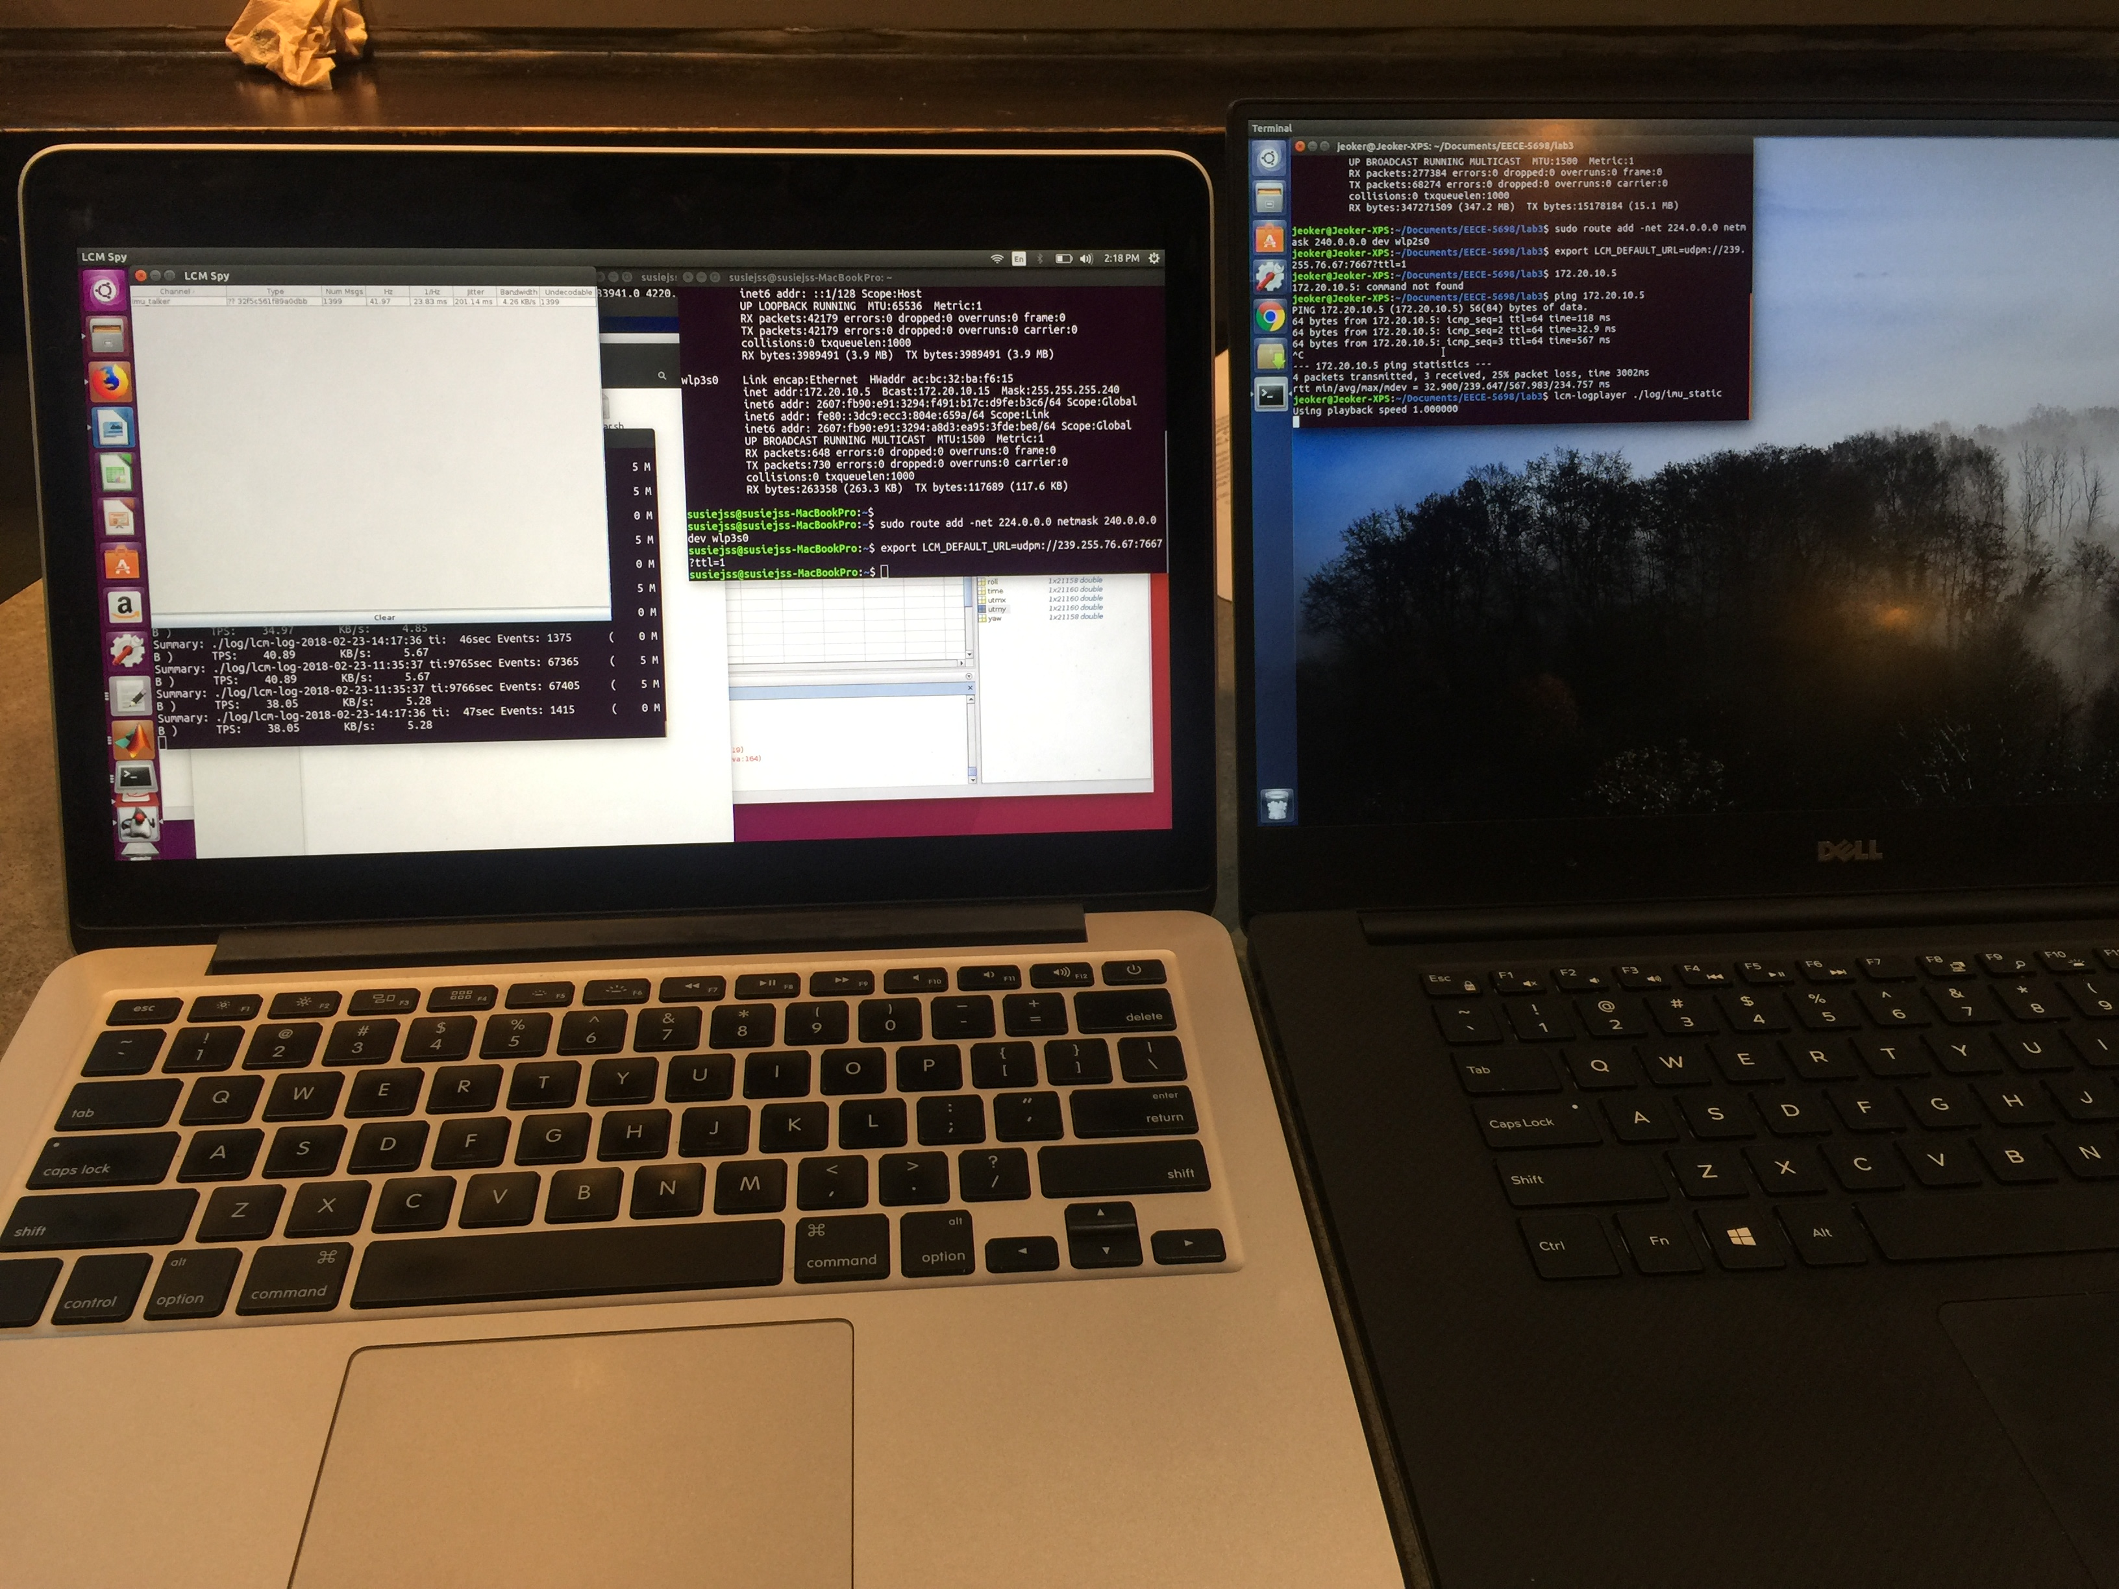

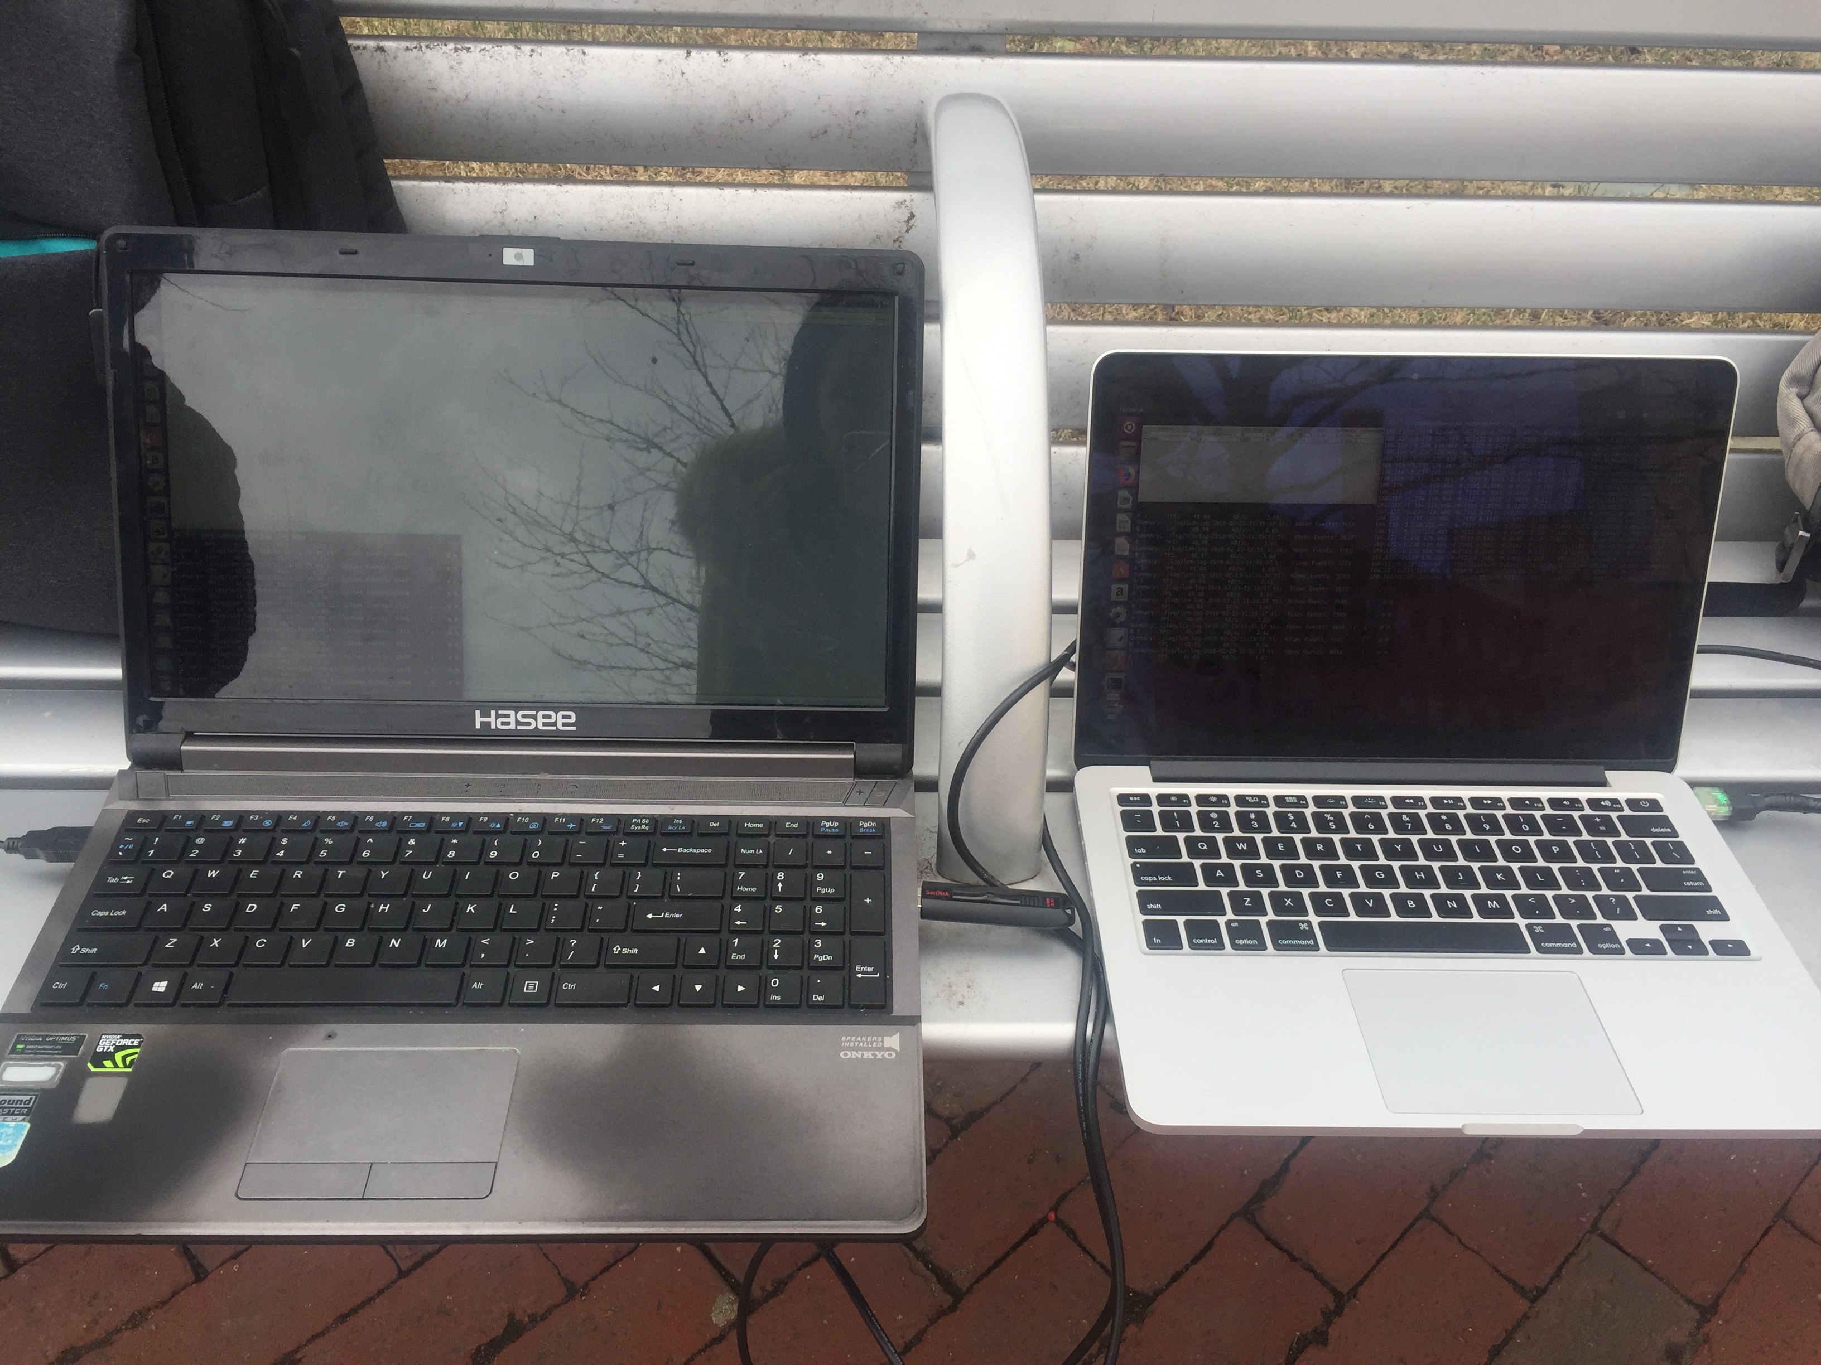

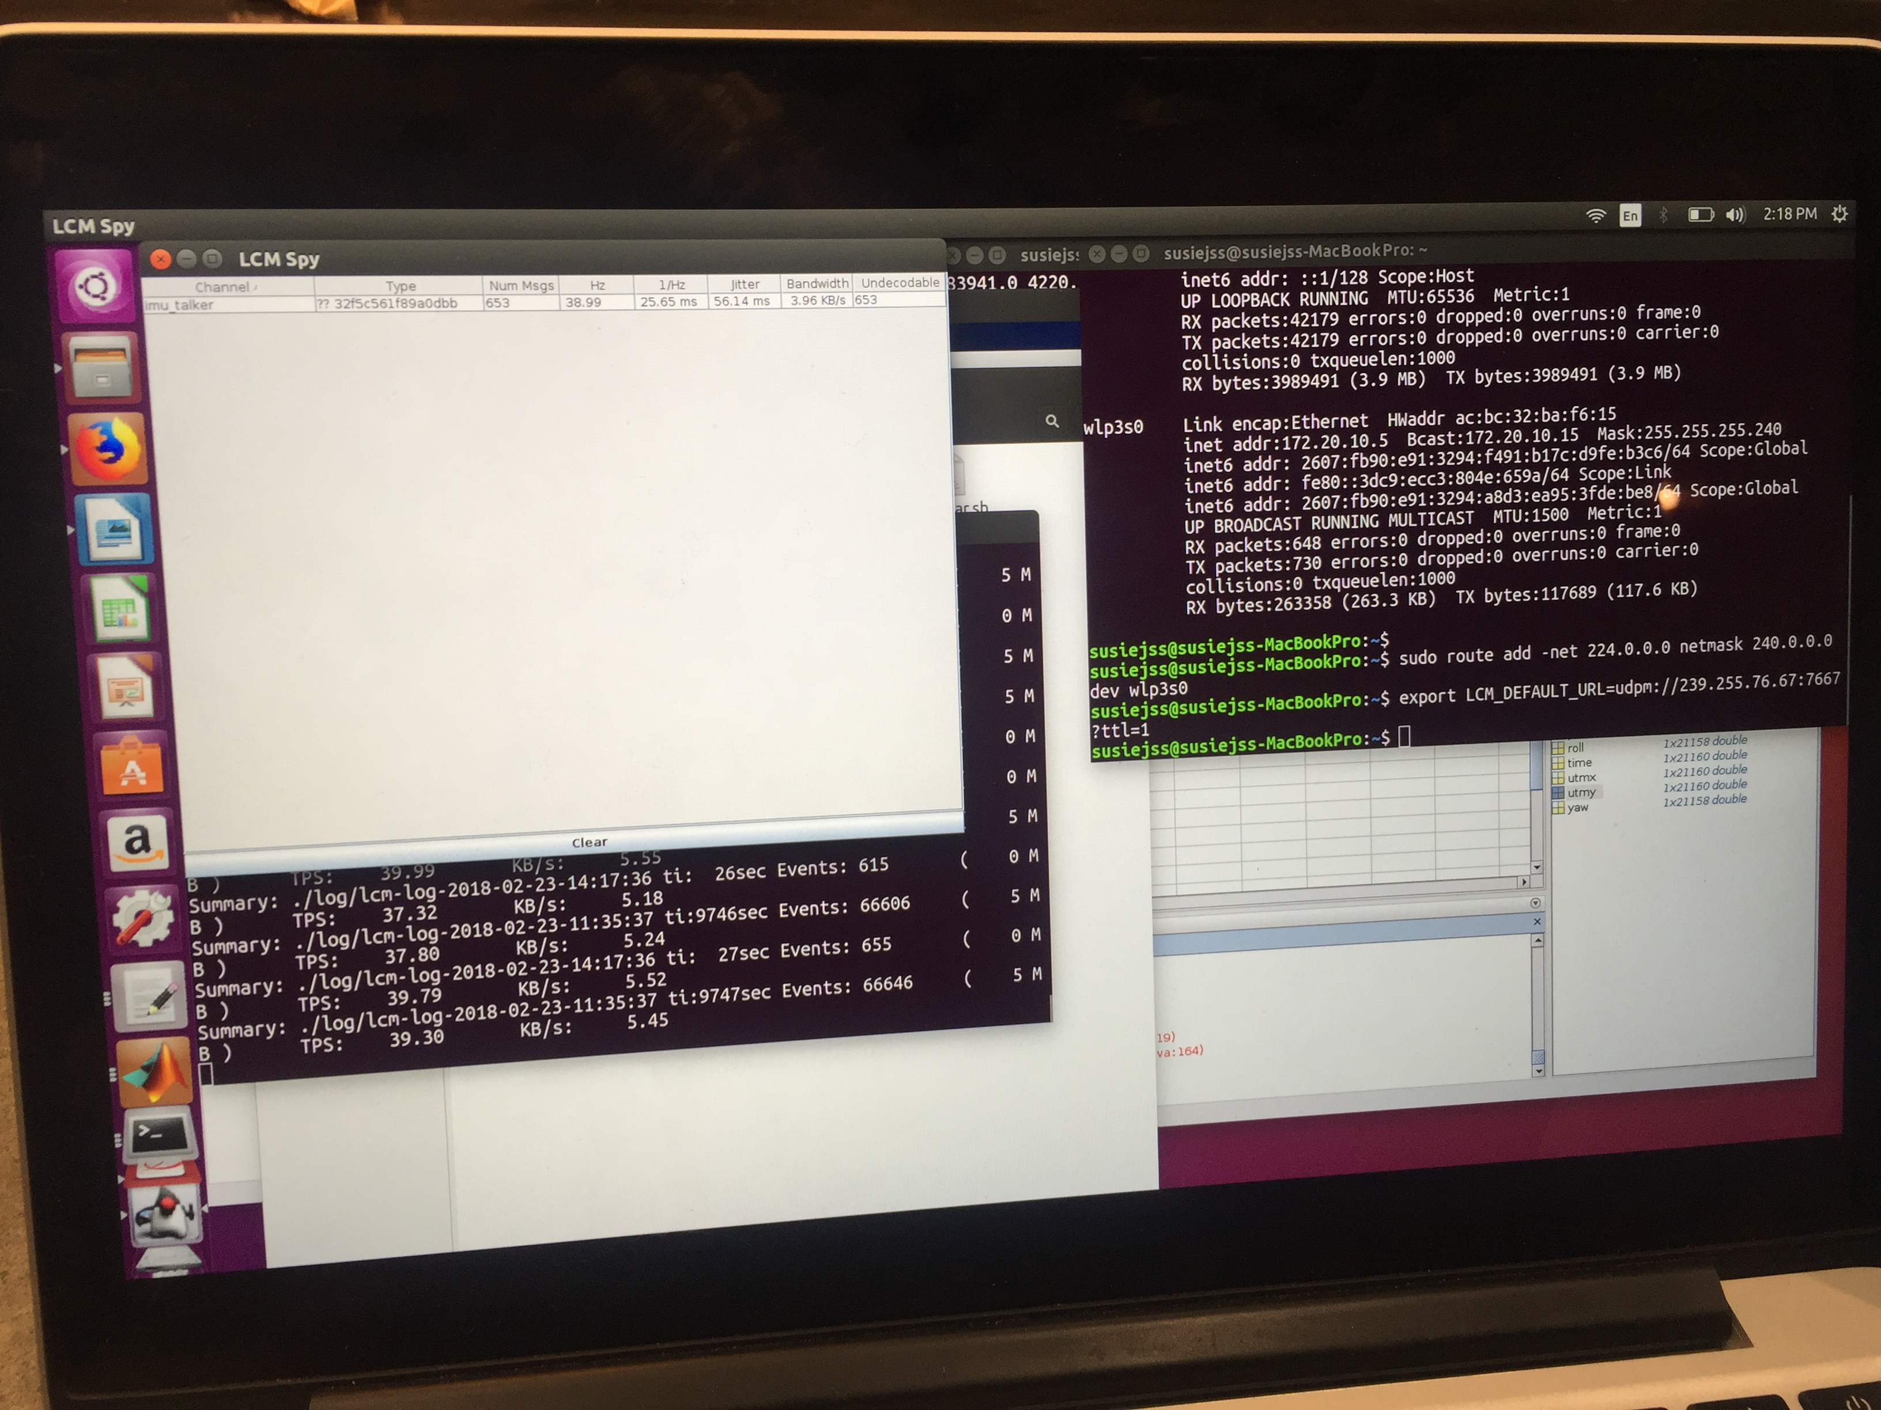

**2. Noise in IMU data**

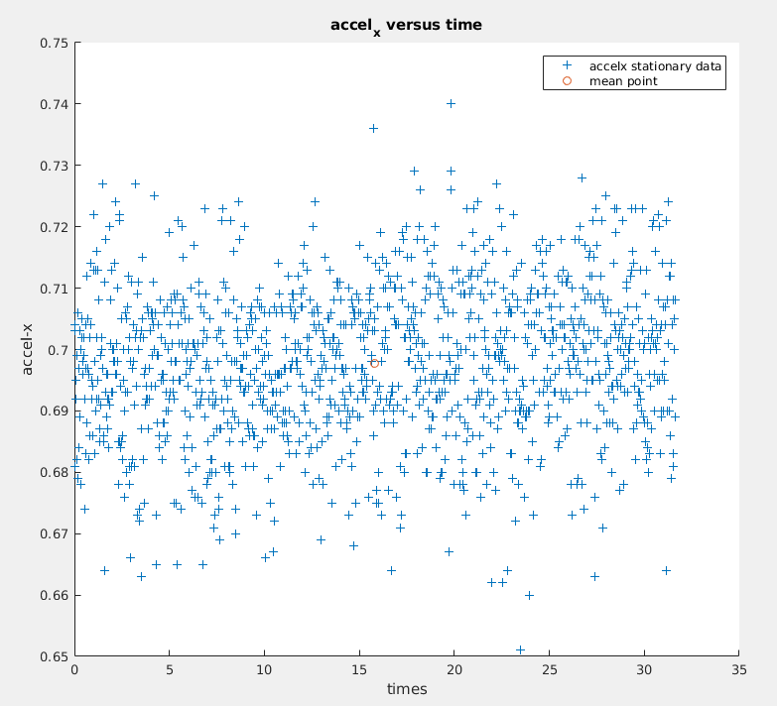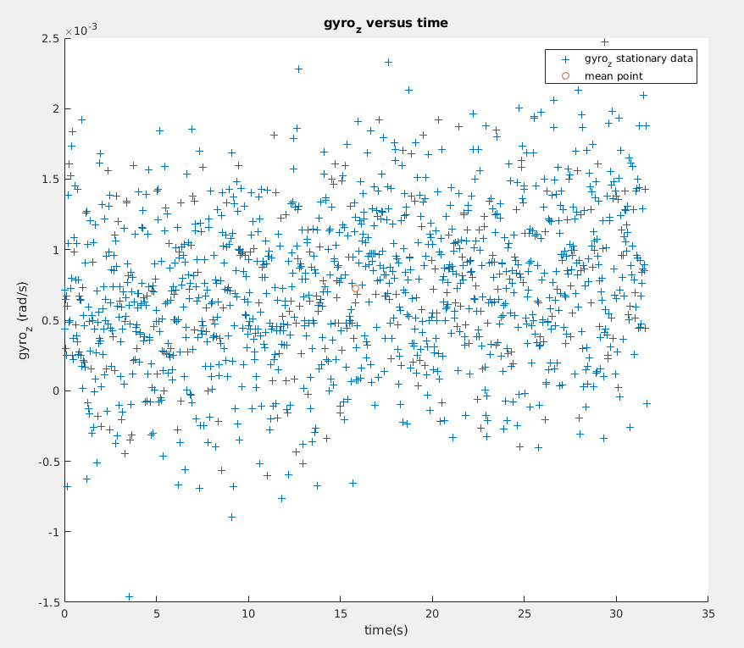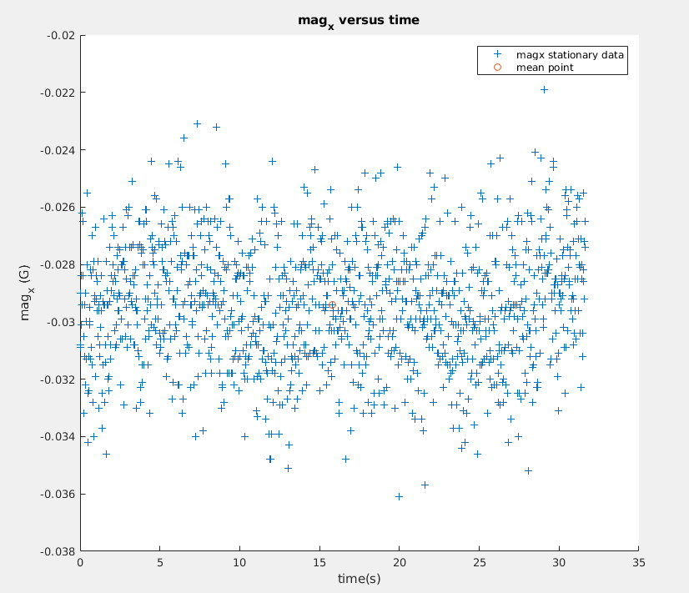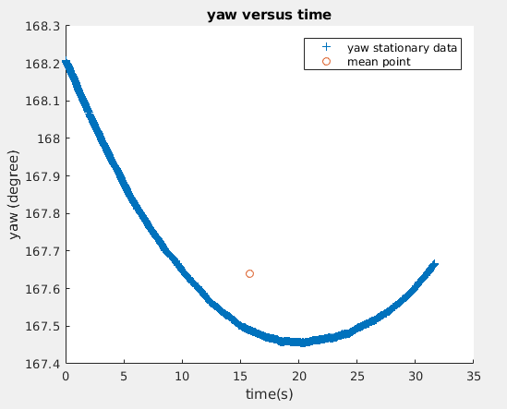

These are some examples of noise data distribution, which will be used later.

accel_xnoise = 0.6977

gyroznoise = 7.2275e-04

magxnoise = -0.0294

**Data processing part**

**1. Correct magnetic readings.**

As shown in figure1, original IMU magnetometer reading has a center away from (0,0) and different lengths on x and y axis.

Hard Iron- move the center to origin(0,0).

Soft Iron- make the ellipse as a circle with uniform radius.

Below plot shows the corrected magnetometer reading. I fitted a ellipse model on it and got the same length on x and y axis(both 0.5). Also, the center is located at origin.

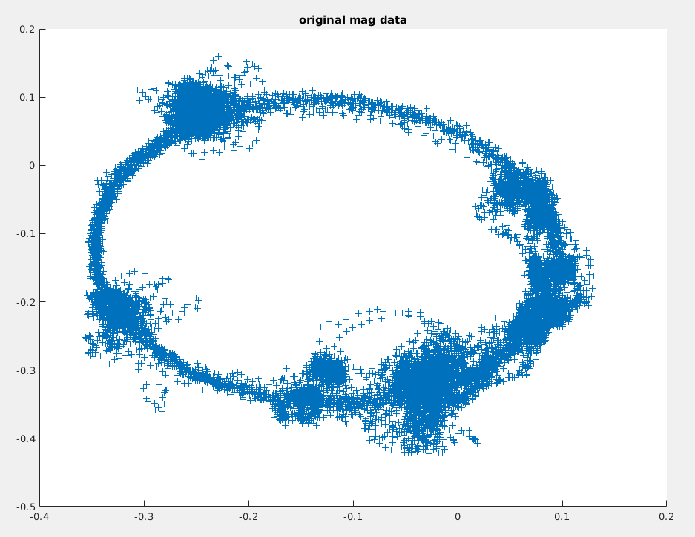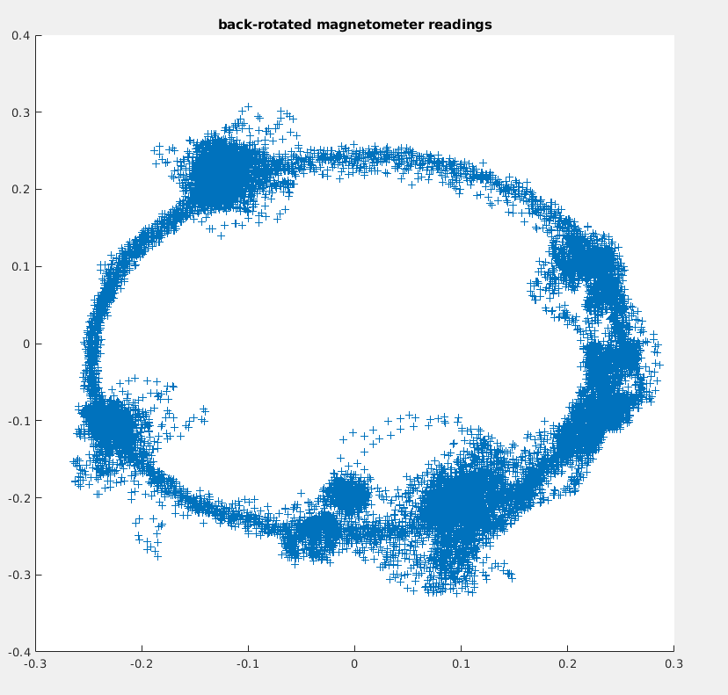

**2. Compare the yaw(before filter) got from 2 methods.**

Below graph shows yaw plots before passing them to filters from both integrated gyro-z and magnetometer reading. (There’s also a result of complementary filter, ignore).

You can see magnetometer reading has lots of high-frequency noises in it, while yaw got from gyro integration has a more smoother plot(almost no high frequency noises). In general, they have the same trend and delay, almost completely overlap.

There’s a bit offset between 2 results but I’ll adjust them later after passing them to filters.

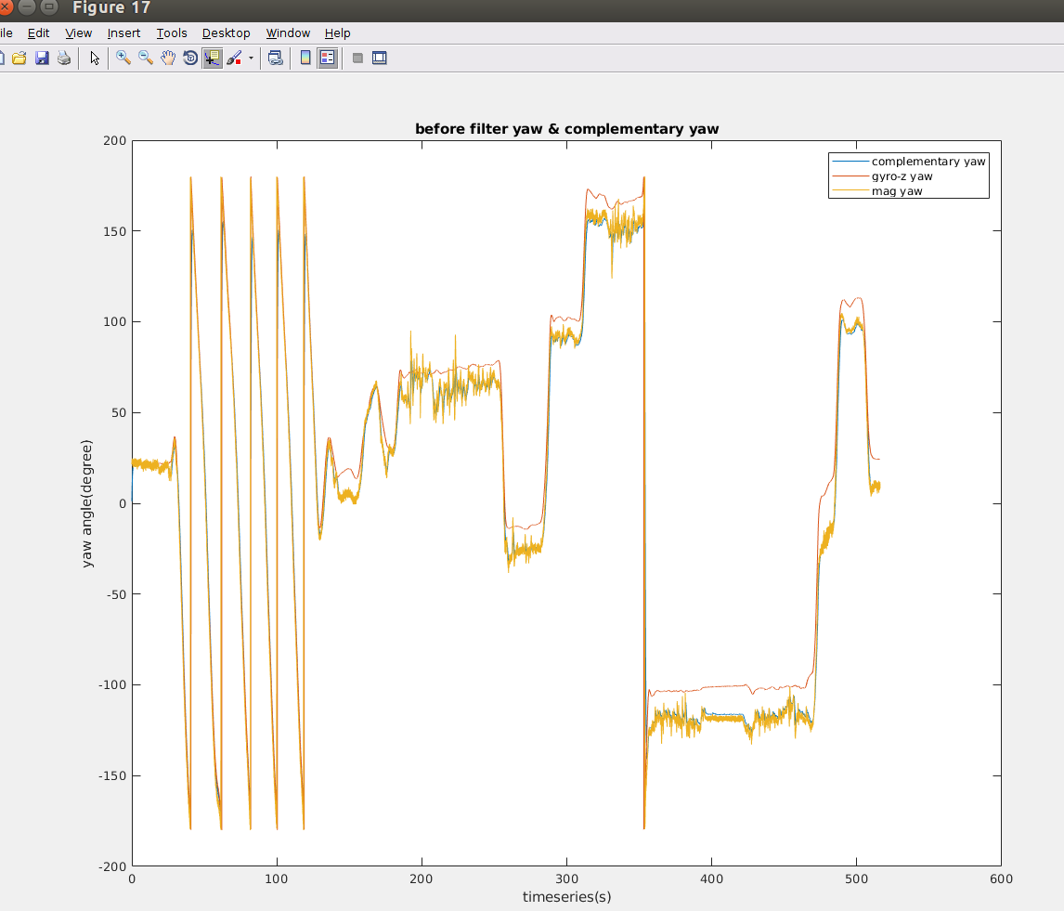

**3. Compare the yaw after filter with IMU.**

Below first graph shows 2 filtered yaw angle compared to complementary filter result.

You can see :

after filter, magnetometer reading is smoother than it was before low-pass filter. Yaw from gyro-z integration becomes much shaper than it was.

Result from complementary filter almost completely overlap with magnetometer reading because I set alpha to 0.98 for magnetometer reading.

Plot2 shows comparison between yaw from IMU and yaw from complementary filter. They have some offset in between(I’ll adjust later to make sure they have the same starting heading).

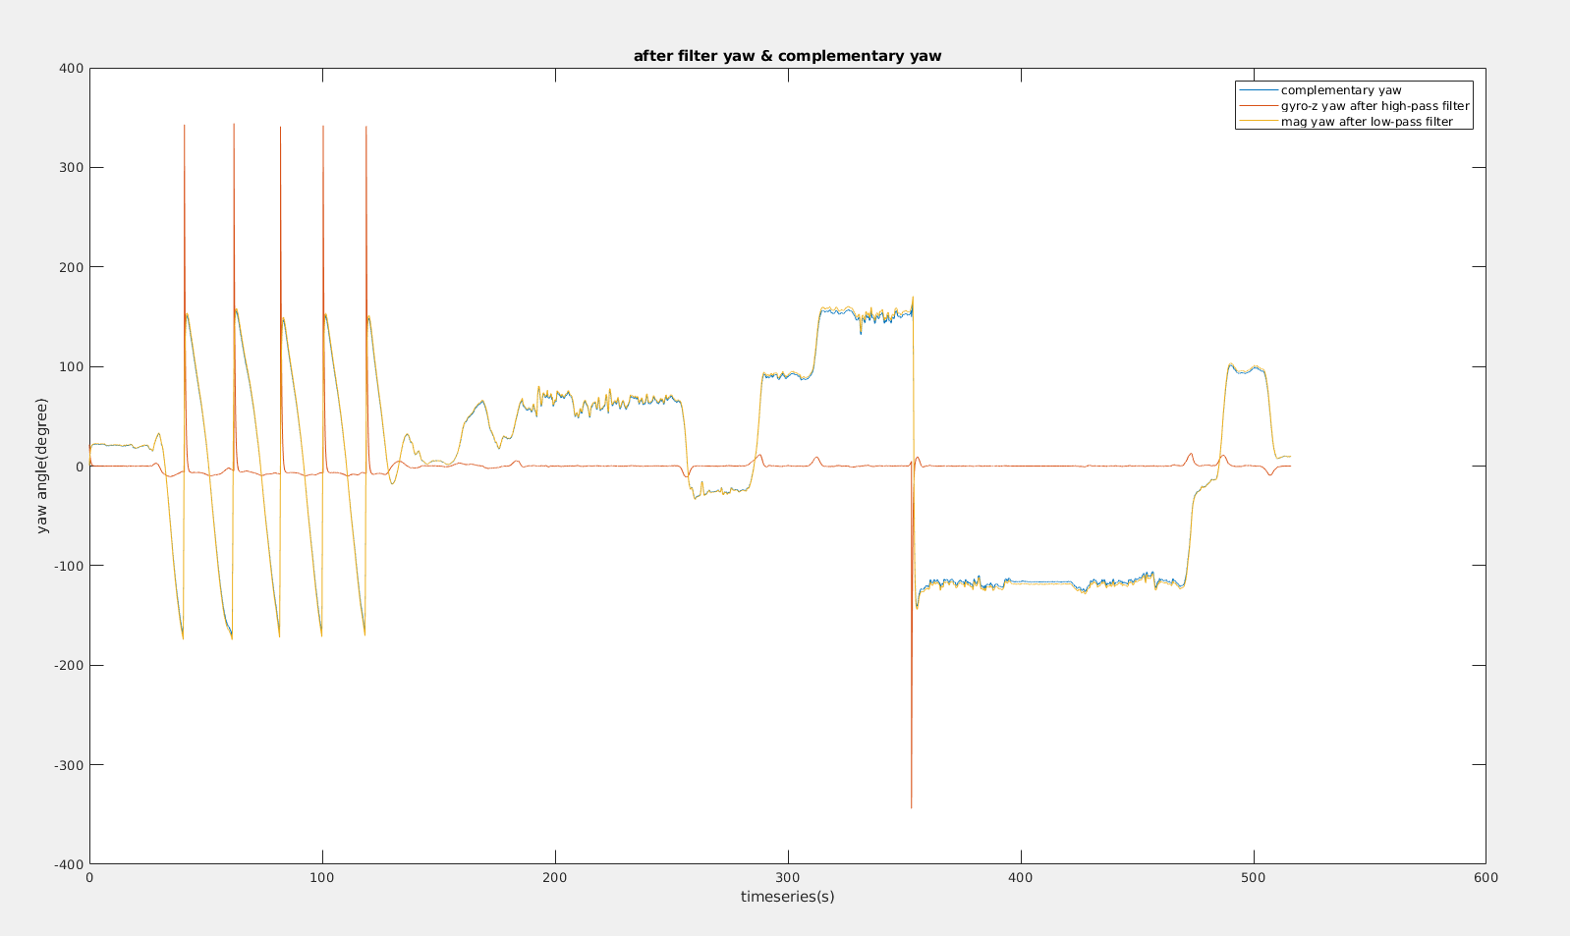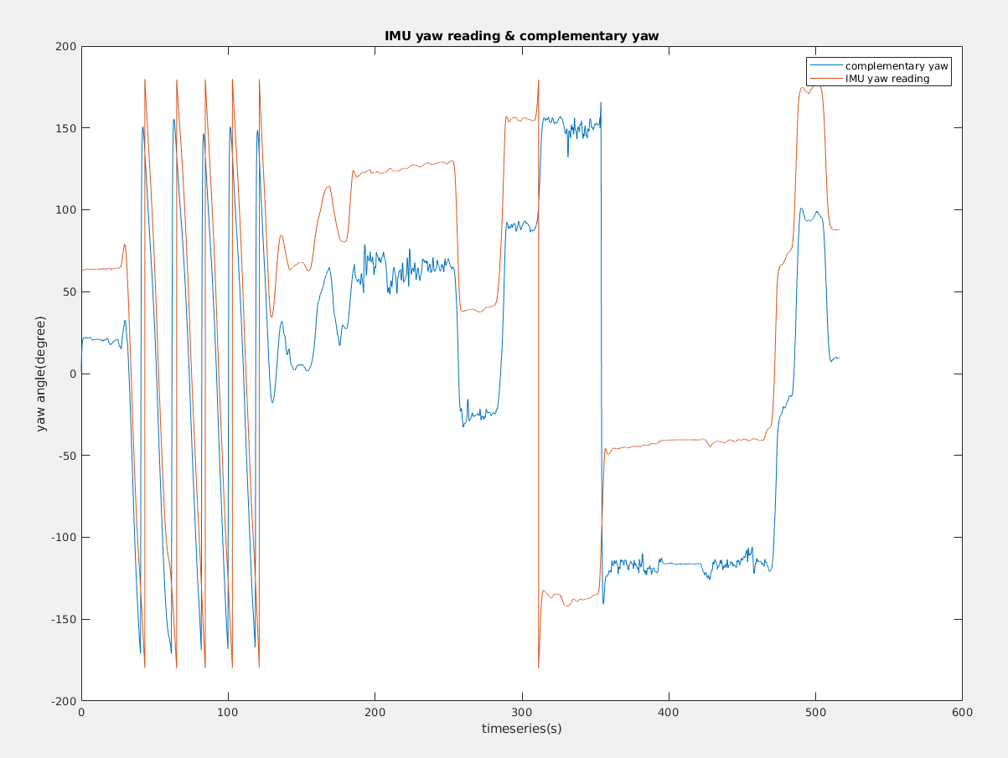

**4. Integration part**

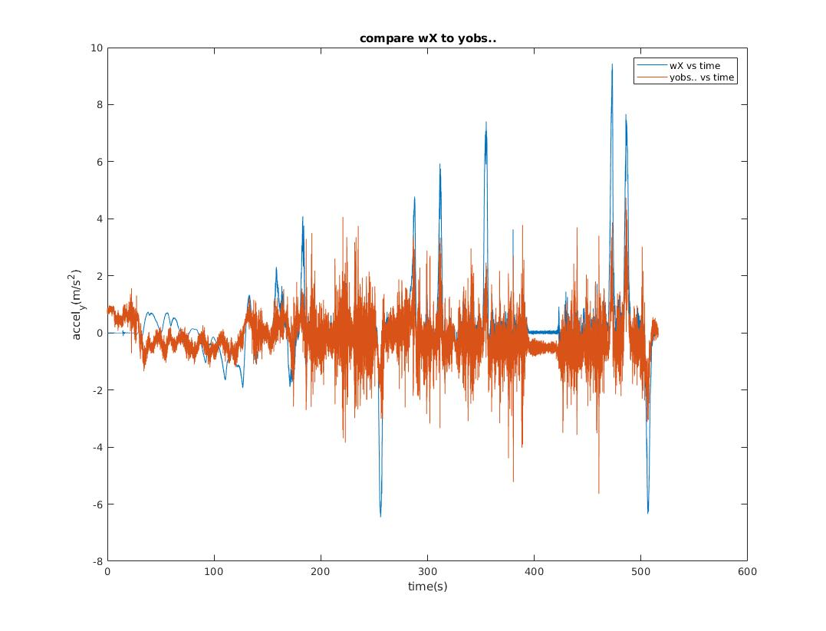**4.1 Compare accel_y and wX.**

You can see from the graph that they have lots of differences but share the same trend.

The small differences in detail may caused by ignoring the xc. Because there must be some difference between CM position and IMU position, which can’t be ignored to get an accurate computation.

The other reason I can guess is the noise in gyro reading but it’ll only be a very small value.

**4.2 Compare the trajectories.**

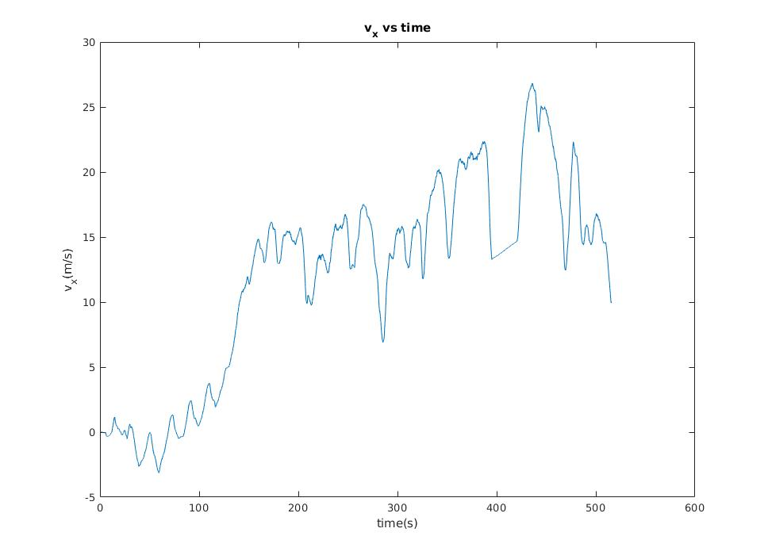First, I integrated accel_x to get v_x. To make it look normal, I checked where we stopped the car and fixed the accel_x data from these points.

Also, I notice there’s a constant acceleration when we drove so that it makes velocity go up and up to a pretty high value, which later was eliminated by canceling the constant acceleration caused by unflat IMU set or road situation.

Below you can see 2 trajectories in graph. I shrank the estimated plot by 1.9 so that they are almost at the same scale.

Another thing I did is to adjust the start heading angle. Originally, they are not in parallel because the different headings. I then rotated the estimated plot by 20 degree counter-clockwise.

Two graph can’t completely overlap. However, the angles are almost the same (except for some small details) to each other so that corresponding lines are in parallel. The reason why they can’t overlap is possibly the velocity ,which is not accurately estimated in the previous step.

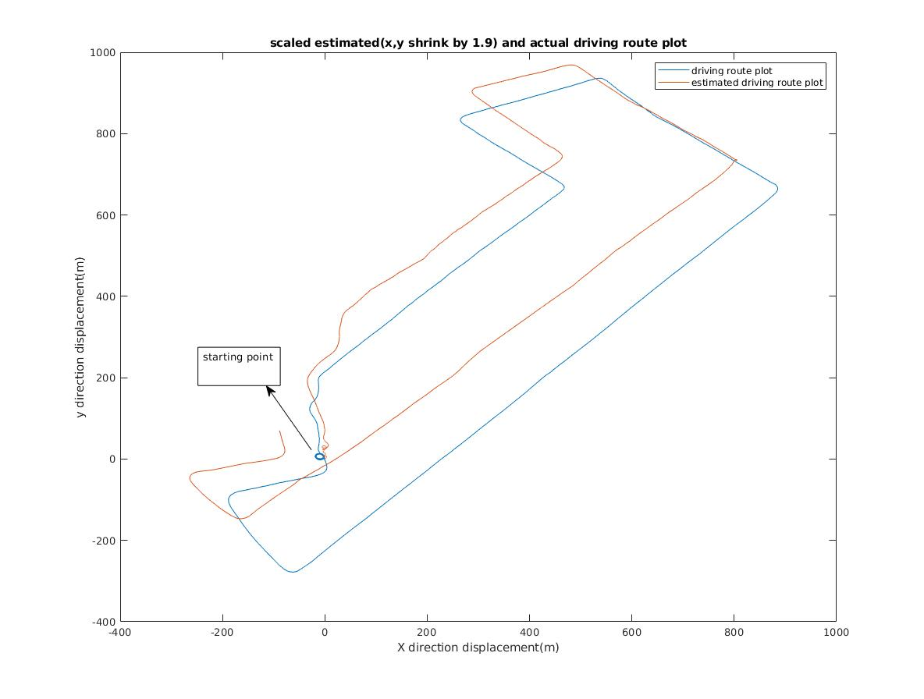

**4.3 Estimate xc.**

My estimation is 0.0752m. After I got X,Y from previous steps, I went back to the formula:

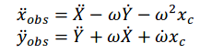

I put the known values into the first formula to estimate xc and got an array of xc, then filtered the noises which are impossibly high and then got the mean of them, which is 0.0752m.